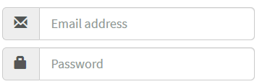

<div class="input-group input-group-lg">  
  <span class="input-group-addon">  
    <span class="**glyphicon** **glyphicon-envelope**"></span>  
  </span>  
  <input class="form-control" type="text" placeholder="Email address">  
</div>

<div class="input-group input-group-lg">  
  <span class="input-group-addon">  
    <span class="**glyphicon** **glyphicon-lock**"></span>  
  </span>  
  <input class="form-control" type="password" placeholder="Password">  
</div>